UNESCO INTERDISCIPLINARY CHAIR IN BIOTECHNOLOGY
UNIVERSITY OF ROME “TOR VERGATA”

UVO-ROSTE Contract 875.771.0 (MPC.9)

Report on the activities

Josefina Calvo Quintana’s chair activities regard Sensors and Biosensors.

Josefina Calvo Quintana’s activity, in the mainframe of the UNESCO chair on Biotechnology, was held in the field of Sensors and Biosensors, developing research and teaching activities.

TEACHING AND RESEARCH ACTIVITIES

- They were held with students having different skills and specializations of the laboratory of the Chemistry Department. A technical support has been given providing technical material, seminars and workshops.

- SENSORS AND BIOSENSORS APPLICATIONS:

Participants:

- 1 Full Professor - 3 PhD students
- 1 Associate Professor - 5 scholarship students
- 1 Assistant Professor
- 1 Visiting Professor
- 1 Post-Doc student

Chemical Sensors: they are miniaturized transducers that selectively and reversibly respond to chemical compounds or ions and yield electrical signals depending on concentration.

SENSORS CLASSIFICATION:

Bearing in mind the different kind of transducers, sensors can be classified as electrochemical, optical and gravimetrical.

The optical signal can be detected by means of spectrophotometry, spectrofluorometry and chemilumenescence. The gravimetric transducers are sensitive to a significative mass change as for example the piezoelectric ones. Electrochemical sensors detect electron transfer and used instruments are potentiometric, amperometric or conductivitic analyzers.

Biosensors can be regarded as a sub-group of chemical sensors, in cases where biological recognition mechanisms or principles are used as a means to recognise substances or molecules. Some types of "biomolecules" isolated from living systems, such as enzymes, antibodies, or receptors, are able to recognise chemical compounds with high specificity and can be adapted to generate signals. Were first described in 1962, even if the term "Biosensors" to describe enzyme-modified ion-selective electrodes appeared in the analytical literature in 1977.
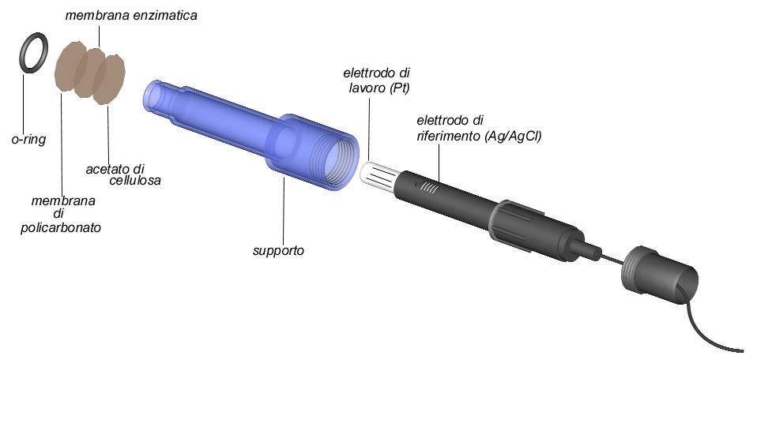
a: before packaging
H₂O₂ ELECTRODE BY UNIVERSAL SENSOR

b: after packaging

APPLICATIONS:

Biosensors are nowadays commercially available for many highly relevant substrates such as glucose, lactate, urea, and penicillin. They are highly superior to chemical sensors, especially regarding selectivity, and would be the ideal sensors, if the lifetime was not severely limited by stability problems.
An important technological application of biosensors is the control of fermentation processes. Here it is desirable to measure continuously, as long as possible, to ensure optimization of the fermentation process and to minimize the consumption of expensive nutrients.
Another field, in which biosensors are used, is food technology and food testing. Some of the useful applications are the detection of the glucose content of wine and fruit drinks, the lactate production during milk processing. Most of the sensors developed so far are based on the combination of microorganisms and transducers. Other systems are used in particular to monitor pesticide contents or heavy metal ions concentrations and the microorganisms inhibition is measured by the decrease of CO₂ production.
A final example of a field in which biosensors are finding application is medical technology. The most frequently performed analyses are glucose and lactate ones, and it is therefore in this area that the most intensive research is being undertaken.

2. K⁺, CA²⁺ AND NH₄⁺ MICROSENSORS CONSTRUCTION:

Participants:

- 1 Associate Professor
- 1 Post Doc student
- 3 PhD student

SENSORS AND BIOSENSORS ARE DESCRIBED BY THREE BASIC COMPONENTS:

- the receptor (the recognition system).
- the part of the instrument aimed to detect a substance-specific signal, in other words to transform an energy quantity into an electrical signal proportional to the concentration.
- the electronic unit (a preamplifier, impedance, converter, analogue-to-digital converter, etc).

MICROELECTRODES
The term microelectrode is used to describe sensors whose tips diameter is in the range 0.2 mm – 10μm. They are characterized by response time several orders of magnitude smaller than conventional ISEs. Microelectrodes based on neutral carriers and ionic exchangers are the smallest available devices and they provide really low detection limits.
One of the lower limits in a further miniaturization is the membrane electric resistance, which is fairly high. (R_{m} = 3.4.10⁹Ω); it is deeply affected by the composition and the geometry of the tip. Studies on several different environments were carried out by means of microelectrodes. Anyway, they are mainly concentrated on heterotrophic organisms. The most important applications concern the study of the distribution of the oxygen in microenvironments such as sea sediments and antarctic environments, but even in biofilms and microbial matrix. The application of microsensors to pH, calcium and potassium measurements are less widespread. Microsensors for the intracellular analysis have been set up in order to measure the concentration of different ions in vegetal cells. The most common microelectrodes nowadays are those measuring oxygen and pH, especially in the study of the chemical transformation and the photosynthesis of the sea microbial community. The main advantage of Microsensors is the very small size of the sensing tip while disadvantages are that they are much more fragile and difficult to prepare than macro-sensors, i.e. they are not the instruments of choice for routine.

MICROSENSORS CONSTRUCTION
3. DIFFERENT FAST SILANIZATION TECHNIQUES OF A GLASS SURFACE; CHOICE OF REAGENT AND EFFECT OF EXPERIMENTAL PARAMETERS ON HYDROPHOBICITY, IN ORDER TO OBTAIN THE BEST RESULTS IN THE MICROELECTRODES CONSTRUCTION:

Participants:

- 1 Full Professor
- 1 Associate Professor
- 1 Assistant Professor
- 1 Visiting Professor
- 1 Post Doc student

The liquid membrane utilized to set up the indicator microelectrode is a solution made of an organic hydrophobic solvent that will be pushed away by the hydrophilic glass surface. As a matter of fact, the glass surface shows roughly 8 μmol/m² hydroxyl groups, which correspond to 4.6 free hydroxyl groups per 10 nm² of glass. This high density makes the organic membrane easily substituted by the aqueous solution in which the electrode has to be dipped. In order to avoid any trouble due to this phenomenon e.g. extremely short lifetime, Walker proposed in 1971 the silanization to be carried out:
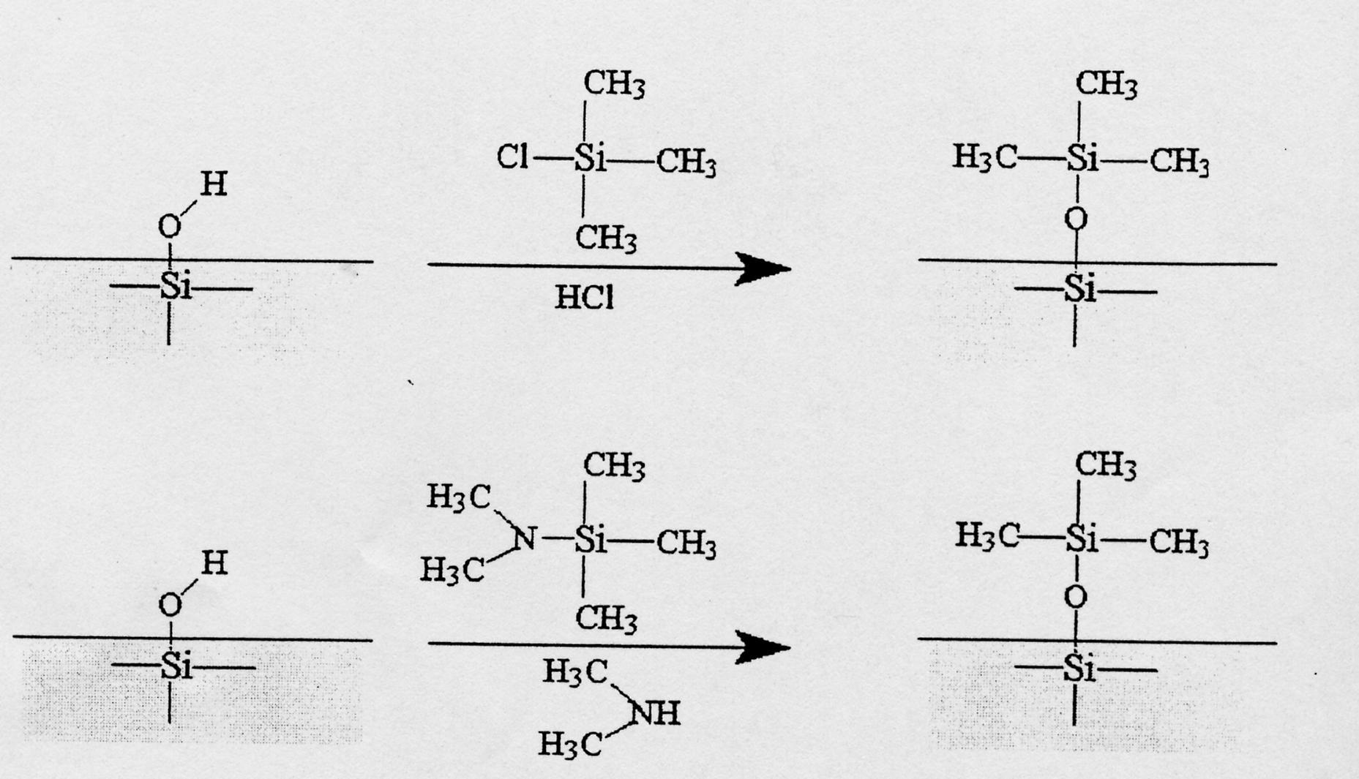

Hydroxyl groups react with silica organic compound and chloridric acid vapors are released. The glass surface is so covered by a thin film of organic groups and becomes hydrophobic, a shown in the figure below.

Most recommended procedures are variations of two basic methods:

- The dip-and- bake methods: Tips of micropipettes are dipped in a dry silane solution for 10 to 15 seconds and then baked in a preheated oven at 180° C for at least 24 h.
- The vapor exposure-and-bake methods: pre-drying of the micropipettes for one h at 180°C, and sequent treatment with the silane in the vapor phase at 220 ° C for 30 minutes.

- GENERAL OVERVIEW UPON CHARACTERISTIC PARAMETERS USED TO DESCRIBE THE ABOVE MENTIONED MICROSENSORS:

Participants:

- 1 Full Professor
- 1 Associate Professor
- 1 Assistant Professor
- 1 Visiting Professor
- 1 Post Doc student
- 3 PhD students

CALIBRATION PARAMETERS:

- Slope .
- Correlation coefficient
- Response time
- Life time
- Low limit of linear response
- Practical detection limit
- Linear range
LOW LIMIT OF LINEAR RESPONSE: it is the minimum ion activity value from which on the electrode response follows the Nernst law. It can be graphically evaluated by the calibration curve.

PRACTICAL DETECTION LIMIT: it is the lower concentration limit that can be detected with the sensor, and can be obtained by means of a linear extrapolation of the nernstian zone (high concentration) and the non-nernstian zone (low concentration) of calibration curve.

RESPONSE TIME: it is one of the most important sensor characteristics i.e. the time taken by an electrode to give a stable measurement.

LIFE TIME: it is the time passed since the filling of the capillary body with the membrane to the moment in which some of the most important characteristic parameters of the electrode are starting to change

CALIBRATION: the so set up electrodes are left for 24 hours in the electrolytic solution to be conditioned. To check whether they work properly they are coupled either with a reference Ag/AgCl microelectrode or with a calomel chloride macroelectrode.

Potassium: KCl solutions in the range between 10⁻¹ and 10⁻⁵ M (NaCl 0.1 M) to be sure the slope is of about 59 mV.

Calcium: CaCl₂ solutions in the range between 10⁻¹ and 10⁻⁵ M (KCl 0.01 M) to have a slope of 28 mV.
Ammonium: NH₄NO₃ solutions in the range between 10⁻¹ and 10⁻⁴ (NaCl 0.05 M) with a slope of approximately 59 mV.

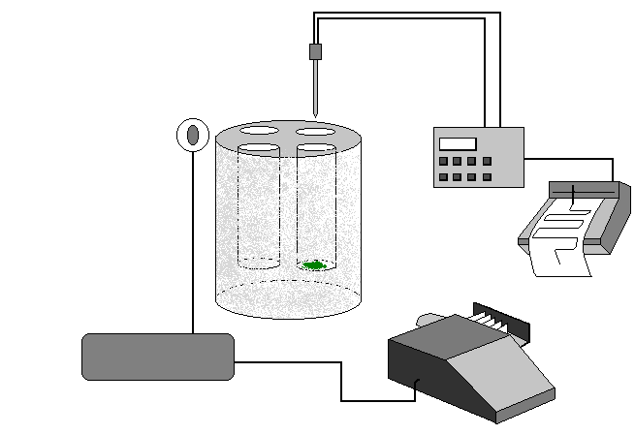
Laboratory measurement equipment.
pHmeter
Recorder
Projector
Datalogger
Light sensor
Microelectrode
Thermostatic bath
Cyanobacteria Biofilms

POTASSIUM

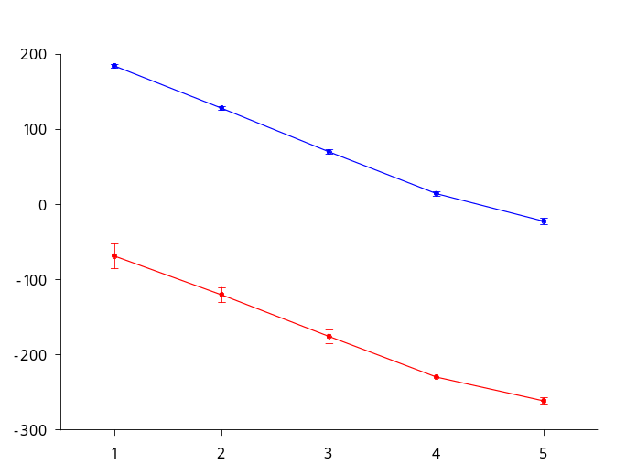
The calibration curve has been done in standard KCl solution in the range 10⁻¹ – 10⁻⁵ M. Microsensors set up this way show a linear behavior in the range 10⁻¹ – 10⁻⁴ M. Values of potential were reproducible and stable for calibration curves repeated in three different days (n=3). The calibration curve of a commercial potassium microelectrode is reported for comparison. As can be easily seen, the microsensor set up in the laboratory shows a better slope (56.8 mV) and a better reproducibility of the measured values of potential.
Slope = 56.8 ± 0.3 mV
r² = 0.999
n = 3
Slope = 53.8 ± 2.9 mV
r² = 0.977
n = 3
E (mV)
- log [KCl] M

Calibration curves of a potassium microelectrode set up in the lab (--) and of a commercial K⁺ microelectrode (--).

APPLICATIONS

The culture medium in which the 3 cyanobacteria strains grow contains K⁺ at a concentration of 0.2 mM. This medium has been used as a blank in the same conditions and with the same microelectrodes used for the biofilms, and it has been constant during 1 hour of dark and even at increasing irradiance.
Results due to the metabolic activity of two strains of S. julianum (CSC7 e CP6) show a similar decrease in the [K⁺] of about 160 μM for the CP6 and of about 200 μM for the CSC7. They show a close behavior in the response as the density of the photon flux grows. The variation due to the metabolic activity of S. ocellatum (CP8) was 5 times greater than the ones observed in the other two species. In previous experiments S. ocellatum showed a greater photosynthetic activity which can be accounted for the higher metabolic activity and therefore the need for more intracellular potassium.

In Table are reported the millimolar potassium concentration measured in 3 different biofilms. In this case no significative variations have been observed as the applied irradiance was increasing. Furthermore, the concentration of this ion is much higher compared to cultured strains, as a consequence of the greater availability of ions in the medium.

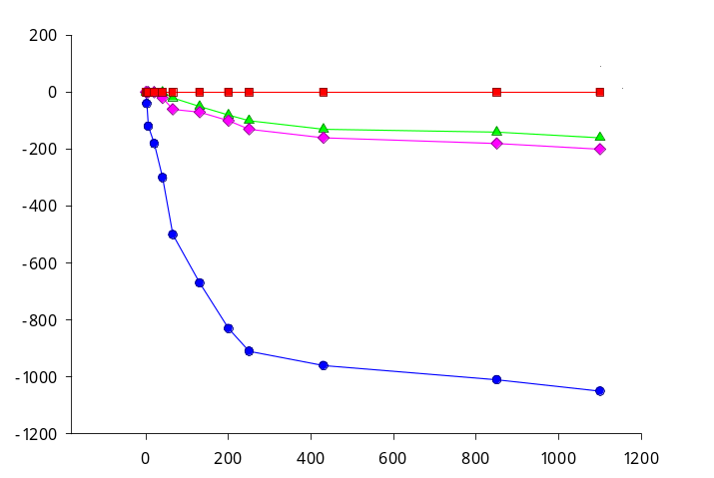
Blank
CSC7
CP666
CP8
Irradiance (μmol photoni m⁻²s⁻¹)
ΔK⁺ (μM)

[K⁺] µM variations into the three cultured Scytonema strains at increasing irradiance sgrows. Blank in growing medium (BG11₀).

Biofilms | [K⁺] mM  Mean value ± St. Err.
CSC 15 | 3.3 ± 0.5 (n = 5)
CSC 19 | 2.2 ± 0.3 (n = 5)
CD 18 | 7.3 ± 1.8 (n = 9)

Average mM values and relative standard error for potassium concentration in three potassium biofilms collected in situ.

CALCIUM
Calcium Microsensors set up in the laboratory showed a linear behavior in the range between 10⁻¹ and 10⁻⁴ M of CaCl₂ and can be used up to a 10⁻⁵ M concentration. Even in this case the calibration curve of a commercial calcium microsensor is reported in red. The slope is nernstian in both cases, even if the laboratory made electrode shows a better reproducibility.

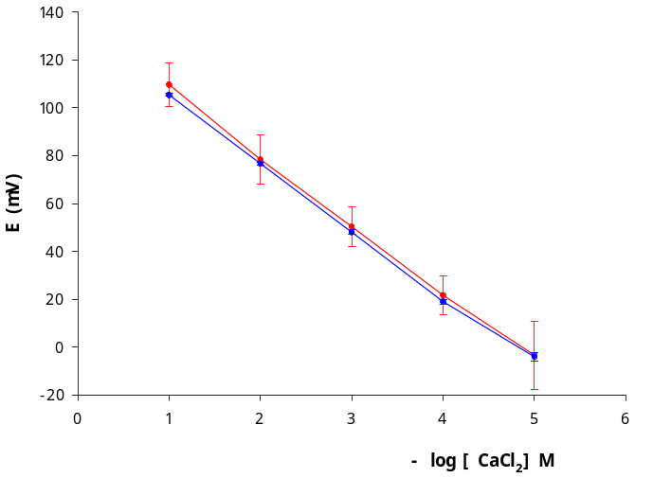
Slope = 29.2 ± 0.8 mV
r² = 0.951
n = 3
Slope = 28.7 ± 0.2 mV
r² = 0.999
n = 3

Calibration curve of a calcium microsensor set up in our laboratory (•) and of a commercial Ca²⁺ microelectrode (•). n = 3 days.

APPLICATIONS
Culture strains | [Ca⁺⁺] mM  Mean value ± St. Err.  (n=3) | Biofilms | [Ca⁺⁺] mM  Mean value ± St. Err. (n=2)
CP 6 | 0.6 ± 0.3 | CD 13 | 29.0 ± 0.1
CSC 7 | 0.30 ± 0.06 | CD 15 | 6.9 ± 0.5
CP 8 | 0.70 ± 0.04 | CSC 16 | 12 ± 2

The measurements, at increasing irradiances have been performed both on the strains cultured in BG11₀ and on natural biofilms. Results showed that no significative variations of calcium took place during the experiment. As shown in Table, calcium values measured in biofilms are much higher in comparison with the concentrations measured in the strains. This difference pops out for some cyanobacteria that can precipitate in situ carbonate crystals on the polysaccharide membranes and therefore they can move calcium from the calcareous surfaces. This skill is lost by microorganism grown in liquid medium. In both cases the mobilisation seems to be light-independent.
Average calcium concentration values (mM) and standard error measured both in three cultured strains and three natural biofilm. n = number of measurements.

REPRODUCIBILITY
 | Slope (mV)
Electrodes |  | K⁺ | Ca²⁺ | NH₄⁺
1 |  | 56.4 | 29.6 | 53.0
2 |  | 57.5 | 28.7 | 54.5
3 |  | 56.2 | 28.9 | 54.5
4 |  | 56.2 | 28.7 | _
5 |  | 57.0 | 28.3 | _
Mean V. |  | 56.7 | 28.8 | 54.0
Std. Dev. |  | 0.6 | 0.5 | 0.8
% S.D. |  | 0.2 | 0.2 | 0.5

Slope values in mV for 5 tested K⁺, Ca⁺⁺ and NH₄⁺electrodes. The average of the slope, the standard deviation and the relative standard deviation are also shown.
Potentiometric electrodes set up in the laboratory showed a good reproducibility of the values of the potential for the same electrode in different days (as shown in the previously reported calibration curves). They also show a good reproducibility for different electrodes. The slope in mV for 5 different electrodes (K⁺, Ca⁺⁺ and NH₄⁺) is shown in Table. As it could be easily seen there is a nernstian response in every situation. For the ammonium electrode the preliminary results are reported.

